**Title:** Pilgrimage

**Platform:** PC

**Target:** 15+

**Rating:** PG15

**Game Summary:** In a world full of mysteries and monsters, the traveler ventures beyond the safety of his town, Seliana, to fulfill his brother’s dying wish, to have his remains scattered alongside his family. Join the traveler’s journey as he faces unfathomable creatures, reminisce his old memories, and treacherous paths as he fulfills his brother’s final wish.

Follow the traveler as he grows as a person and learn to deal with the loss.

**Game Outline:** The traveler is a very agile and meticulous adventurer and that is shown in his controls. Players will enjoy a high skill-cap fast paced movement system that will make the player feel good when traversing the levels. The movement system is inspired by the Titanfall series and Ghostrunner. The world is a hybrid of Open-World and Theme-park inspired by Tombraider and Ashen and will offer parkour challenges, dangerous enemy encounters, light navigation puzzles and well kept secrets.  
  
In order for The Traveler to complete his brother’s wish he will need to acquire a set amount of key items from different types of trials. These can include but are not limited to: Parkour challenges and puzzles. Along the way, players will encounter deadly enemies and monsters, and, as the traveler is no fighter, players will have to sneak their way from the enemy’s territory, as one mistake could be the player’s last.

**Unique Selling Points:**

* Fluid movement mechanics
* Acquire progressively stronger weapons and abilities
* Beautiful Stylized World
* Deep and engaging story
* Encounter unique monsters and enemies
* Various stealth mechanics to sneak through enemies

**Similar Competitive Product**

Journey, Ashen, Tomb Raider, The Last Guardian

**NOTE:** Some design subject to change

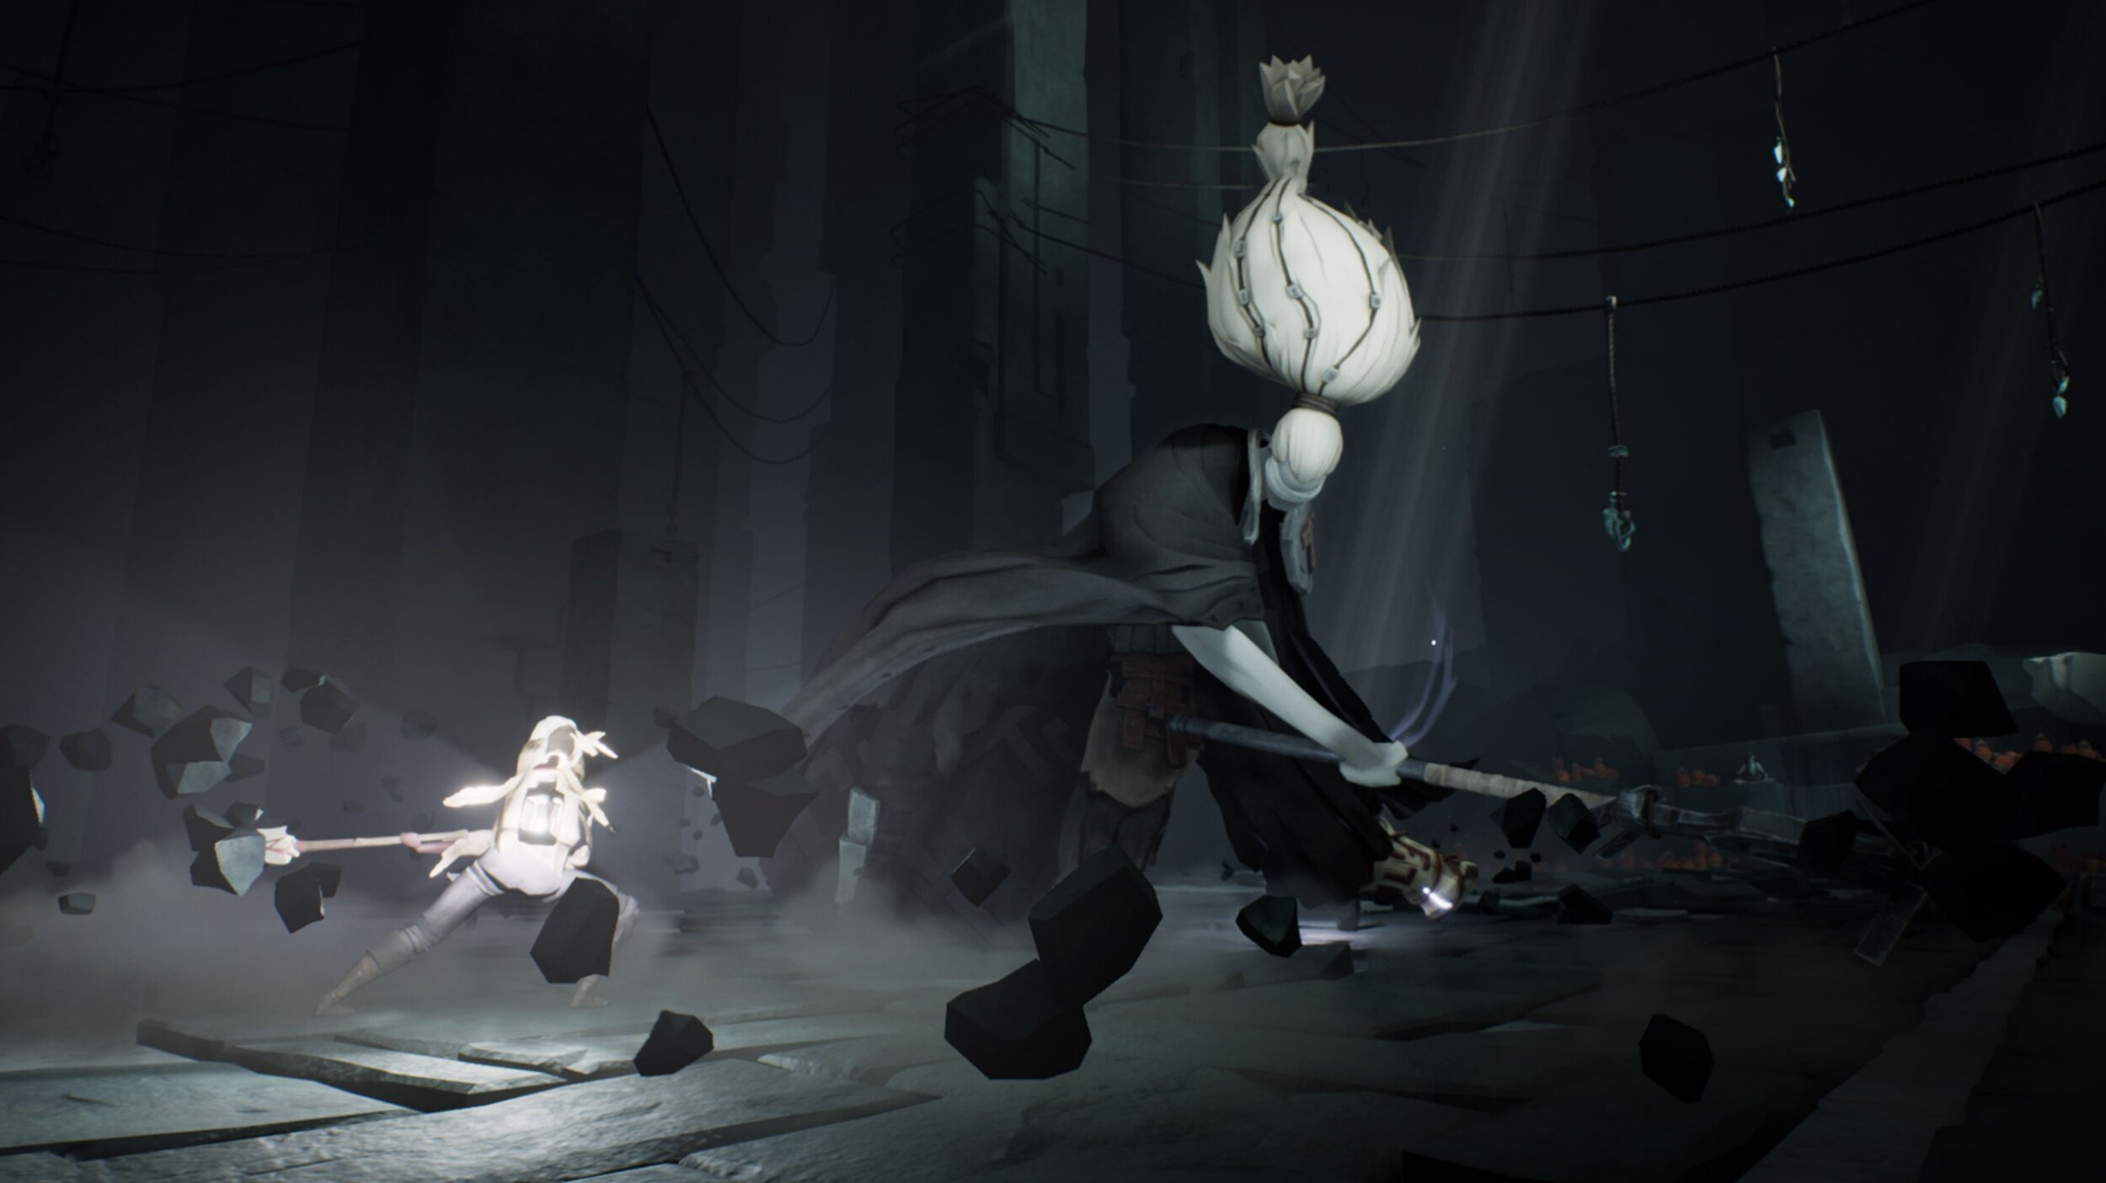

Ashen

Ashen is a game that shares the same world-view as we have for our game, it has open parts where the player is free to explore and choose what obstacle(in this case dungeon) he chooses to tackle next. This gives the player freedom to choose the order in which he wants to complete the objective and also to change his focus to another challenge in case the current one is out of reach.

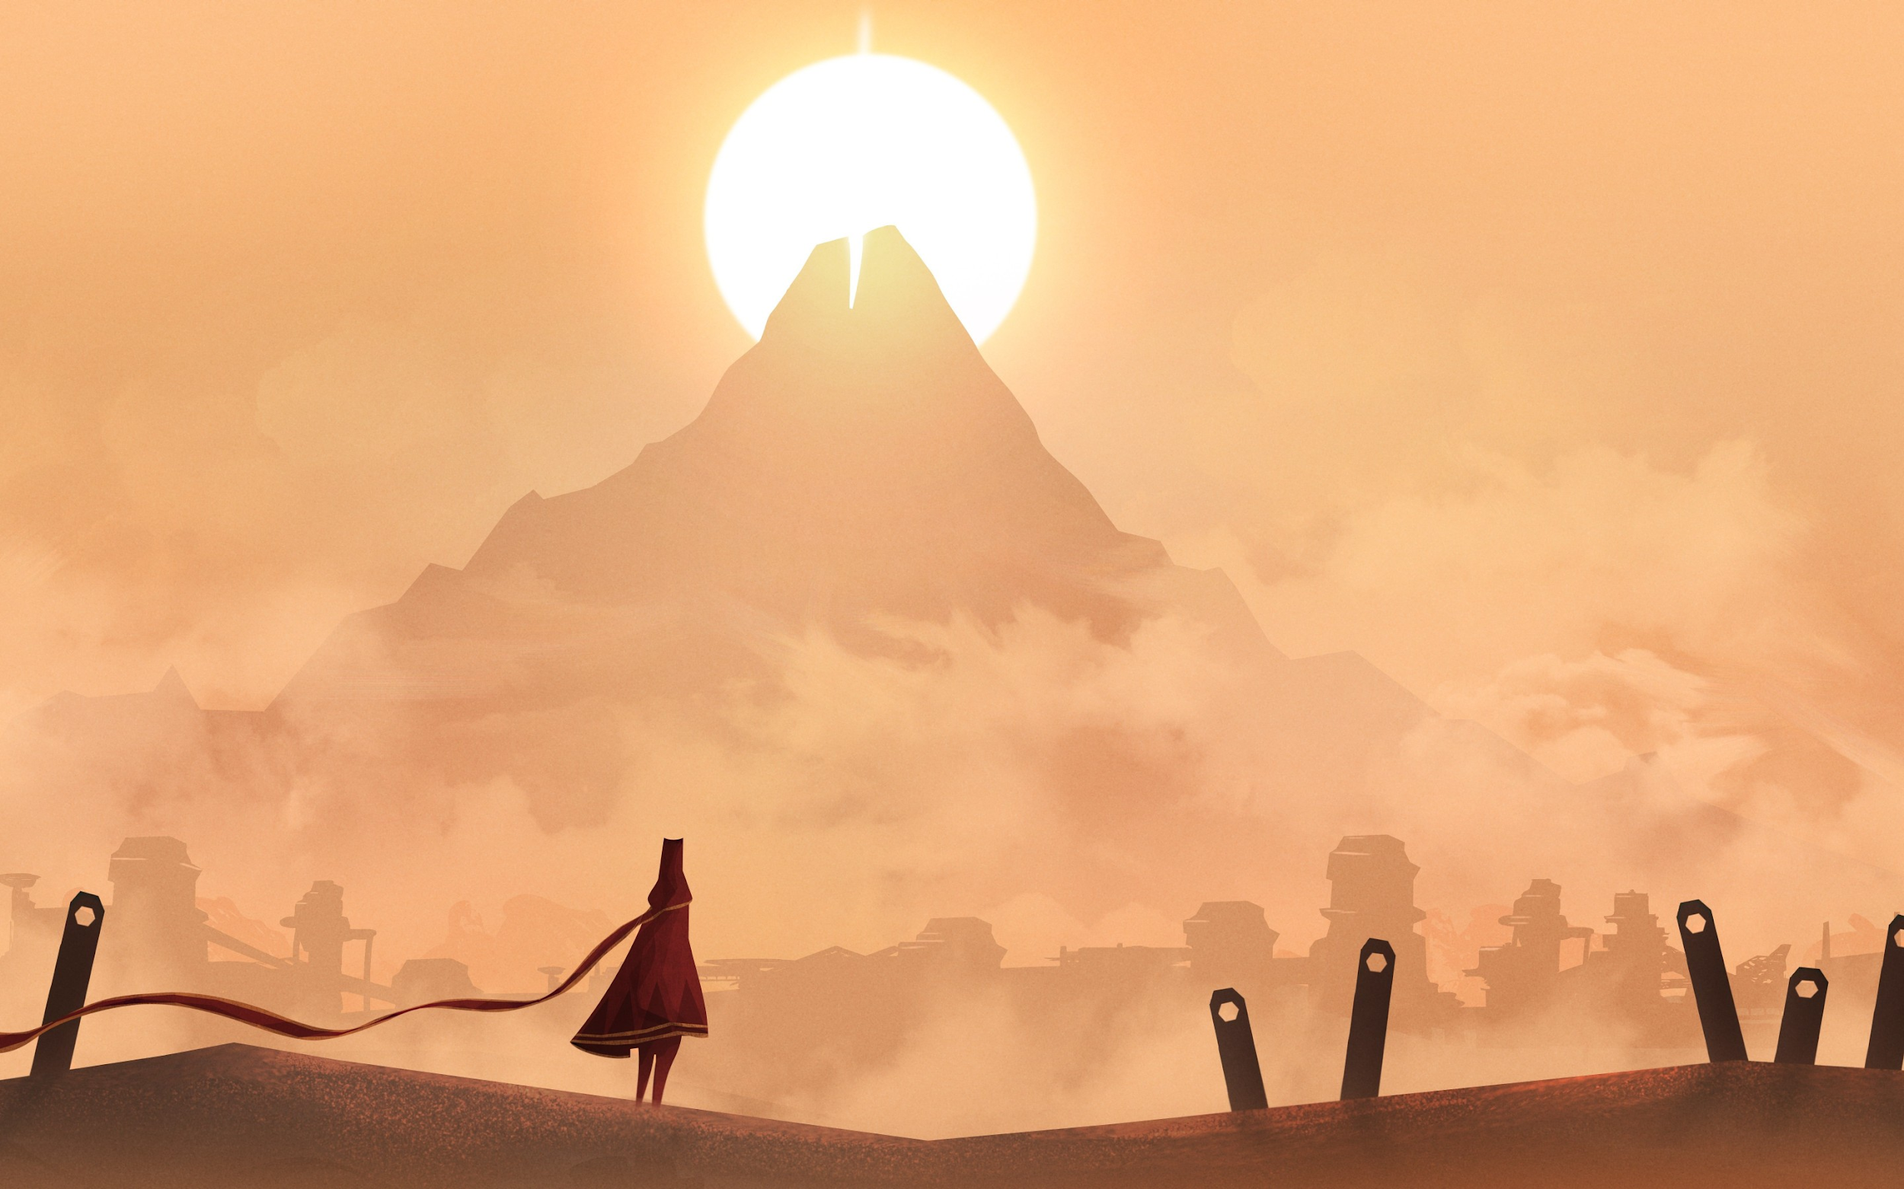

Journey

As the name implies, Journey is a game about a journey the player needs to take, which is the same motif behind the story of our game, however unlike Pilgrimage, Journey contains no enemy encounters.

Tomb Raider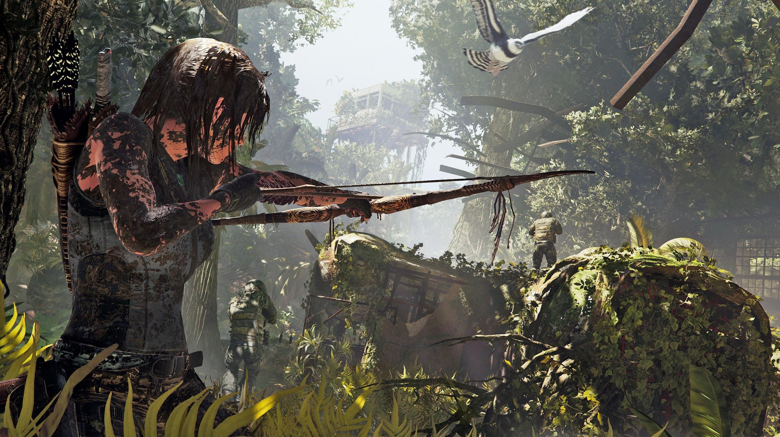

This game offers a similar world design as our game concept, a mix between open-world and theme-park world, where players can choose to be engaged in a linear story with a linear world or they can side-track and explore the world as they please.

The Last Guardian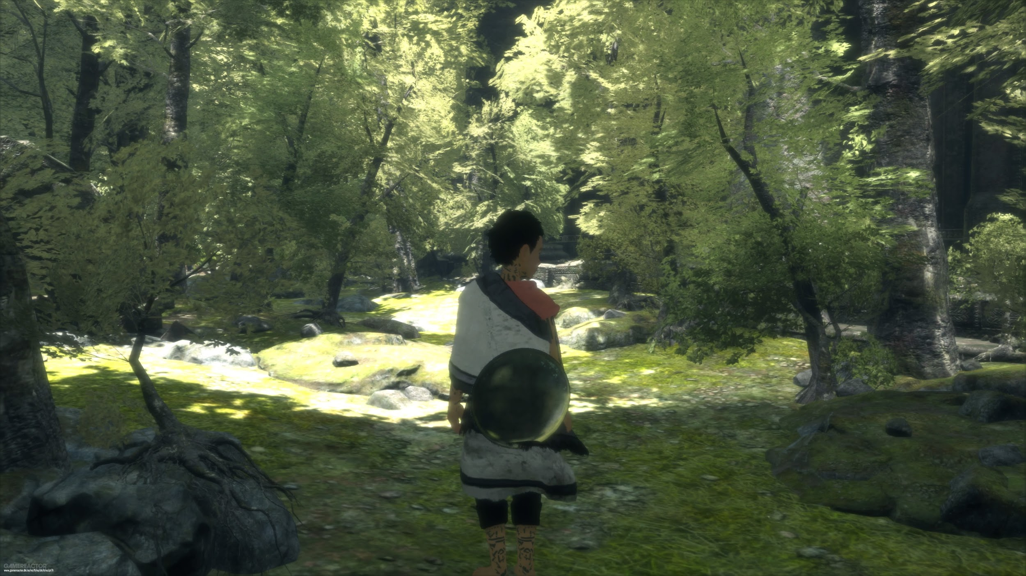

Similar to our design, the story in this game is about a boy who journeys to find his home. The part where the boy journeys to find his home is the same as ours where our character journeys to place to scatter his brother’s ashes.